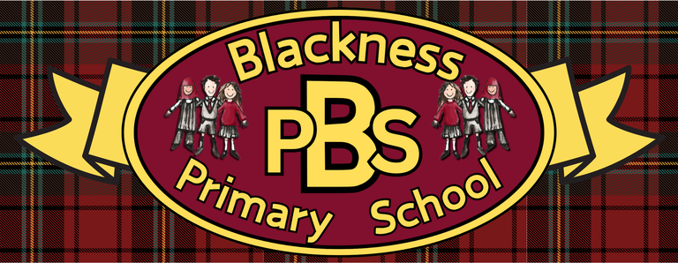 “Everyone Here Matters”
P3 Health and Wellbeing Grid
Developing Healthy Choices  Drinking water  Can you keep a chart across the week of how much water you drink each day. On the day you drank the most record the reasons why. | Nutritional Needs  Draw a blank plate divided into sections matching the Eatwell Guide (Fruit & Vegetables, Carbohydrates, Protein, Dairy, and Fats). Cut out pictures from grocery magazines to make a balanced meal. | Keeping safe  Road safety  Road safety - BBC Bitesize  Watch the clip then have an adult record you crossing the road following the safety rules. | The journey of food  Our food comes from three main sources: plants, animals and water. Can you make a list and record as many items as you can think of for each one. (you may write the words or draw pictures).
Food technology  Can you help your adult cook/bake something where the ingredients need to be measured out. Share what measuring equipment you needed and the standard of measure used. | Physical Activity  Dance  Create a dance routine to a favourite song. Try and teach someone your routine. | Social Wellbeing  Have a phone, video or in-person conversation with a person you haven’t spoken to in a while. Ask them how they are. What have they been doing recently? Share what you have been learning about recently and tell them about events in your life. | Zones of Regulation  Strategies sort (see below)  What strategies help you best when you find yourself in the blue, yelllow or red zone?
Healthy Relationships  Draw someone in yor life as a superhero. Design a costume for them. What is their superpower? | Mental and Emotional Wellbeing  Photography!  Go to https://expertphotography.com/7-fun-photography-projects-children/  to do a photography challenge! Or take a photo relating to one of these themes: happiness, sunlight, family, nature or colour. | Sport  Create a poster sharing your favourite sport. Try and explain why you like it so much. Do you think your poster would persuade someone else to take part? | UNCRC  Can you match the right to the picture?  (see below)

Ready Respectful Safe

Ready Respectful Safe

